EEE 117 Laboratory

Instructor: Sergio Aguilar

Lab 7: PSpice Cadence Simulation

Lab Report by: Sergio Zavala

Lab Session: Wednesday (32490)

Due Date of lab: March 14, 2018

Date of the lab: March 07, 2018

Lab partner(s): Talal Jawaid and Amrit Singh

**Transient Analysis Circuit 1**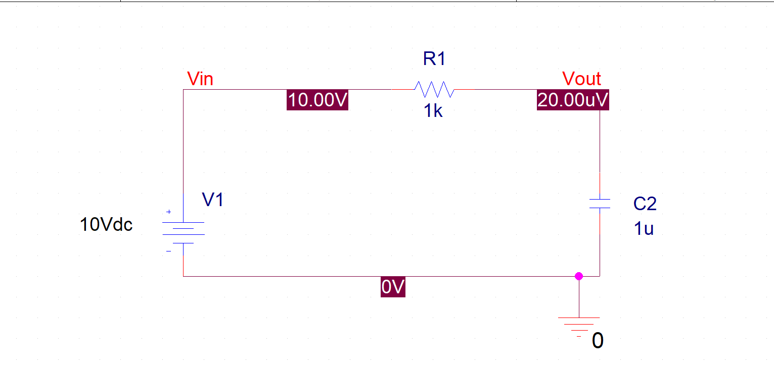

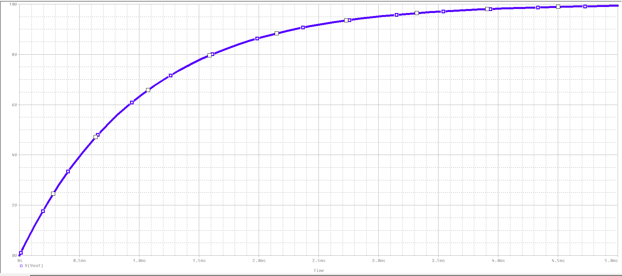

Time

**Transient Analysis Circuit 2**

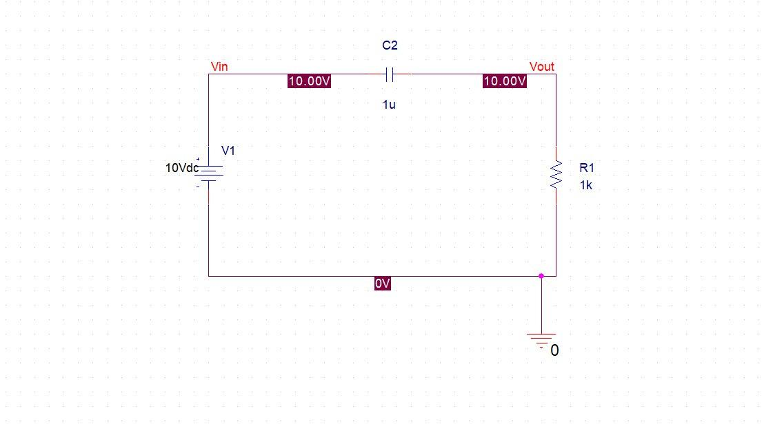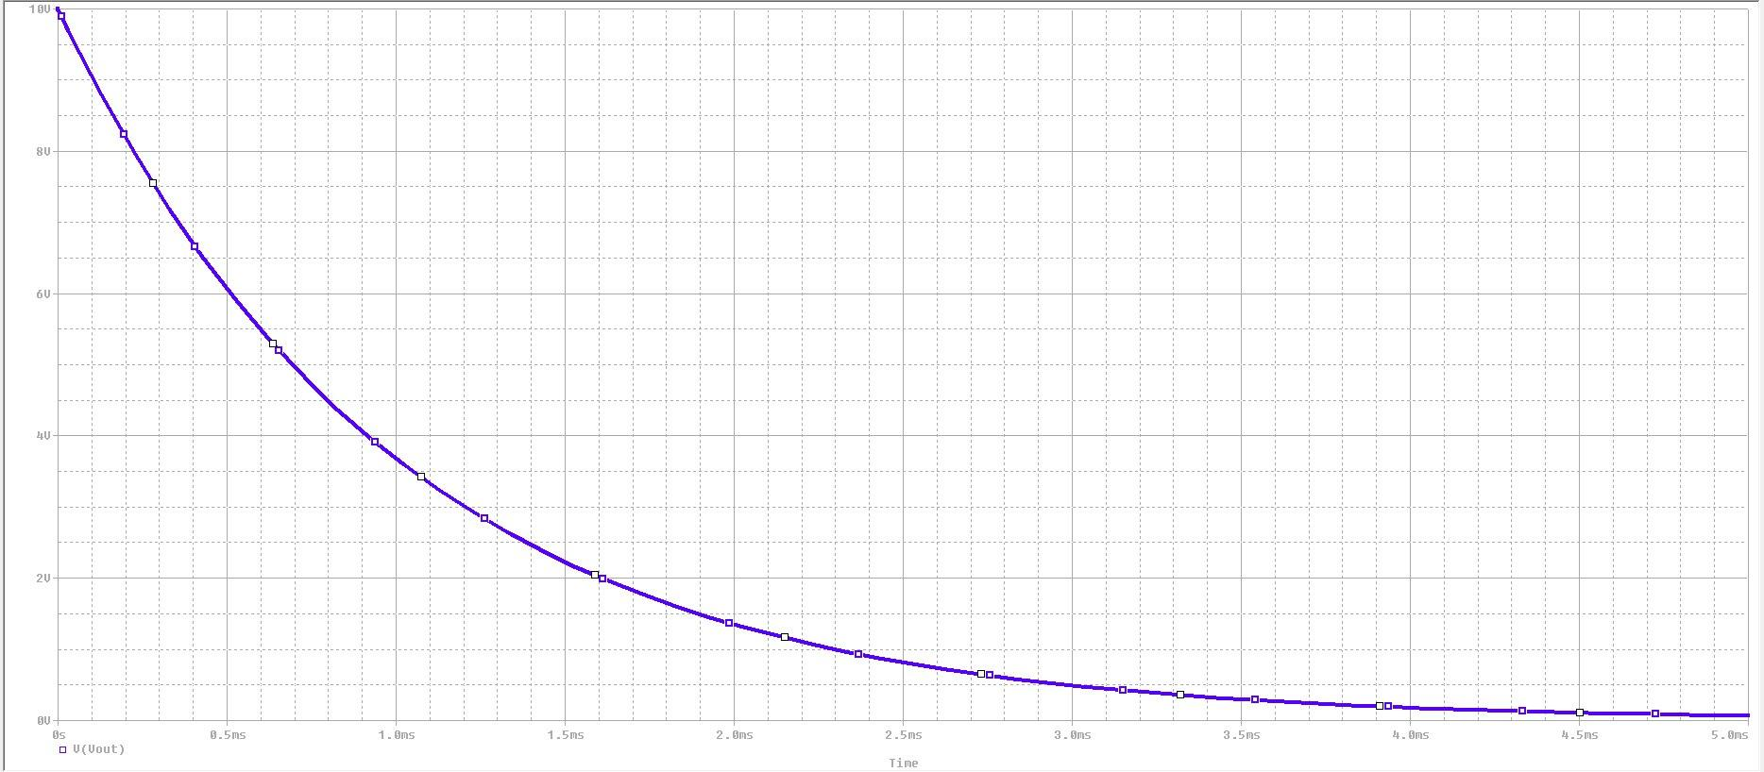

**AC Sweep Circuit 3**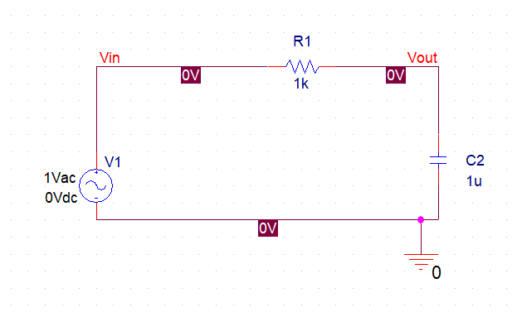

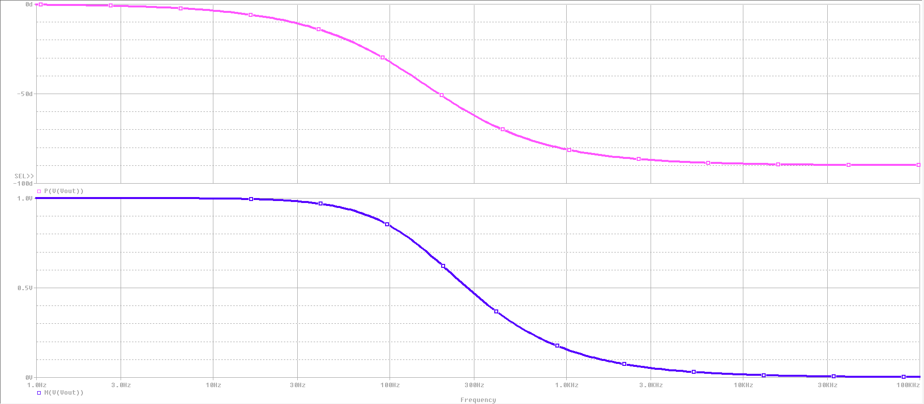

**AC Sweep Circuit 4**

